**ACKNOWLEDGEMENT**



# **BIBLIOGRAPHY**

1. , , “,”., vol. , pp. -, .
2. , *,* , , .
3. IS: -, “”.

# **BIBLIOGRAPHY**

1. ., and , , “,” , Vol. , No. /, pp. -.
2. ., , “,” ., , pp. -.
3. IS: -, “”.

# 

# **CHAPTER**

###### **Format for representing figure, table and equation in a chapter**

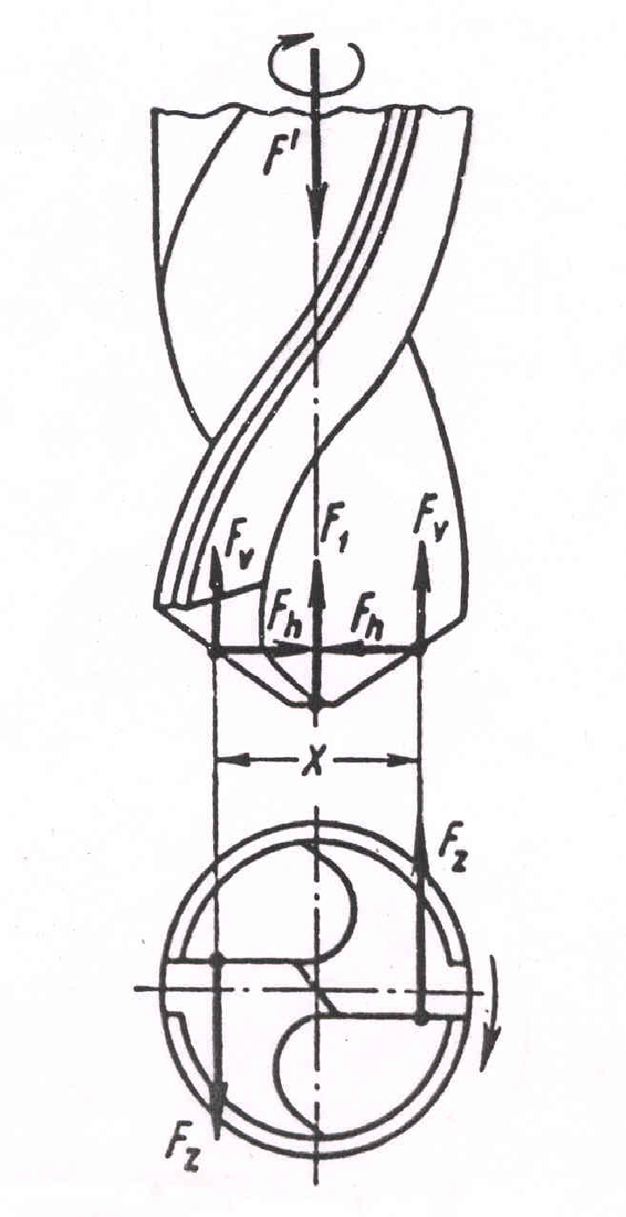



##### **Table 1.1 Comparison of properties between Composites and Metals**

| **Property** | **Graphite/**  **Epoxy** | **Glass/**  **Epoxy** | **Steel** | **Aluminum** |
| --- | --- | --- | --- | --- |
| **Specific gravity** | 1.6 | 1.8 | 7.8 | 2.6 |
| **Young’s modulus (GPa)** | 181.0 | 38.6 | 206.8 | 68.95 |
| **Ultimate tensile strength (MPa)** | 1500 | 1062 | 648.1 | 275.8 |
| **Coefficient of thermal expansion (mm/˚C)** | 0.02 | 8.6 | 11.7 | 23 |



(1.1)

**CONTENTS**

**CHAPTER Page No.**

# **Acknowledgement ……………………………………………..….…………………… ()**

# **Synopsis………………….………………………………………………..…………….. ()**

# **List of Figures** (optional)**………………………………………………...…………….. ()**

# **List of Tables** (optional)**………………………………………………………………… ()**

**List of Symbols, Abbreviations or Nomenclature** (optional)**……………..…….. ()**

1. **…………………………………………………………...**
2. **…………………..…………………………………….**

:

:

:

**N. CONCLUSION………………..…………………………………….……….…….**

**BIBLIOGRAPHY ..…………………………………………………………….…………**

**APPENDICES …………..………………………………………………………….…….**

# **SYNOPSIS**

**FEASIBILITY STUDY ON THE USE OF A DROP DEMAND INKJET PRINTER FOR CERAMIC INKJET PRINTING**

Mohan Kumar P (Roll No: 98GM07) Abhirami O (Roll No: 98GM51) Arul Murugan M (Roll No: 98GM52)

Dissertation submitted in partial fulfillment of the requirements for the degree of

**BACHELOR OF ENGINEERING**

**Branch: MECHANICAL ENGINEERING (SANDWICH)**

of Bharathiar University



April 2003

DEPARTMENT OF MECHANICAL ENGINEERING

PSG COLLEGE OF TECHNOLOGY

(Autonomous Institution)

COIMBATORE – 641 004

##### **PSG COLLEGE OF TECHNOLOGY**

(Autonomous Institution)

**COIMBATORE – 641 004**

Bona fide record of work done by

()

Dissertation submitted in partial fulfillment of the requirements for the degree of

**BACHELOR OF**

**Branch:**

of _____________ University

...……………………… …………..……………….

Faculty guide Head of the Department 

Certified that the candidate was examined in the viva-voce examination held on ………………….

…………………….. …………………………..

(Internal Examiner) (External Examiner)